SW Engineering CSC648/848 Summer 2016

Application: Gatorslist

Milestone 2

July 6th, 2016

Rev 1.0

Team 1

Khalid Alrashed (alrashed@mail.sfsu.edu),

Eric Chen, Robert Chung,

Tai Nguyen, Guoyi Ruan.

Table of Contents

1. Use Cases 3

2. Data Definition 4

3. Functional Requirements 6

4. Non-Functional Requirements 8

5. UI Mockups and Storyboard 10

6. High Level Architecture, Database Organization 13

7. High Level UML Diagrams 17

8. High level APIs 18

9. Key Risks 20

10. Team Organization 20

1. Use Cases

**User-Friendly Home Page**

John is an SFSU student currently in his sophomore year. John had a bad experience buying textbooks directly from the campus store because of how expensive they are, and so this time he decides to go to Gatorslist. On the home page he is presented with a simple layout of textbook images and their titles. He can easily browse through the images and search for the textbooks he needs at an affordable and competitive price.

**Search (Unregistered User)**

Consuela wants to head-start her semester at SFSU and organize her life a little better. Instead of waiting a week or two to get the textbooks required for her classes, she decides to start shopping a little earlier. Only problem is the professors haven’t posted the syllabus yet and she doesn’t know what books she might need, so she goes to Gatorslist. There, she can search and browse by category like Philosophy, or Science for example. She can modify the search and filter by price, date posted, or even write down the major prefix.

**Register and Sell Textbooks**

Rebecca is graduating from SFSU this semester. Over the years at SFSU she has bought many textbooks, and has accumulated a massive collection as a result. But now she’s planning to move out, and doesn’t have the space to take her books with her, so she decides to go to Gatorslist and sell them. On the website’s homepage she can register for a new user account and after that’s done, she’ can go to her account page where she can post her textbooks with the price she prefers and images, along with other optional descriptions of the books. After she submits the post, her account page is updated with the new post.

**Buy Textbooks**

Marc is on the 2nd month of the semester at SFSU, and realizes that he should’ve bought the book for his major class. The book store has just sold out, and will require a special order that will take a long time. Marc can’t wait that long as he needs the book right now. This is where he finds Gatorslist. He searches for the books he needs, and buys whichever satisfies his conditions. He registers for a new account if not yet registered, enters his payment method of choice, and sets up the meeting with the seller within SFSU campus. He can then confirm the transaction after he has picked up the book. Marc is pleased with the time it took to get the book he needed.

**Administrator**

Gatorslist is maintained by an admin user that looks over and manages user accounts along with product listings. If a user submits a book to be sold, it will have to be verified by an admin first before the post become visible to everyone. This insures that users follow post submission guidelines and protects the website’s users from unwanted content.

1. Data Definition

2.1 Term Description

|  |  |  |
| --- | --- | --- |
| **Term** | | **Description** |
| Unverified User | Guest | Browse the website.  Search products.  View products. |
| Verified User | Buyer | Have all rights of unverified users.  Create, login and logout account.  Order products on the website.  Review seller. |
| Seller | Have all rights of unverified users.  Create, login and logout account.  Upload and delete products.  Set/Reset a price for products. |
| Administrator | Have all rights of unverified users.  Login and logout account.  Manage all accounts.  Manage all products. |
| Product | | Information about a particular product includes:   * Product title. * Product id number. * Seller’s id number. * Price. * Quantity. * Description of this product including images. * Post date. * Condition. * Status. |
| Search | | Our site provides search:   * By category. * By seller. |
| Filter | | Filter provides better control to achieve more effective and efficient searches. Our site provides filter:   * By price. * By condition. * By category. * Class prefix. |
| Registration Information | | Includes:   * Username * Password * Email Address |
| Order Information | | Information about a particular order includes:   * Order number. * Product id number. * Buyer’s id number. * Order Date. * Pickup location. * Pickup time. * Detail. * Total price. * Status. |

2.2 Users Permission

|  |  |  |  |  |
| --- | --- | --- | --- | --- |
|  | Guest | Buyer | Seller | Admin |
| Browse website | + | + | + | + |
| Search products | + | + | + | + |
| View products | + | + | + | + |
| View user’s profile | + | + | + | + |
| Reset their own password |  | + | + | + |
| Edit their own profile page |  | + | + | + |
| Order products |  | + |  |  |
| Cancel order |  | + | + |  |
| Rate seller |  | + |  |  |
| View order history |  | + |  |  |
| View saved search |  | + | + | + |
| Add products |  |  | + |  |
| Edit products |  |  | + |  |
| Delete products |  |  | + | + |
| Set/reset price |  |  | + |  |
| Delete user account |  |  |  | + |

‘+’: Permission approved.

1. Functional Requirements

**Guests**

* Guests shall be able to search for and browse items best matched to the search criteria they provided. [1]
* Guests shall be able to filter through their search results based on a predetermined set of filtering options. [1]
* Guests shall be able to sort through search results based on a predetermined set of sorting options. [1]
* Guests shall be able to sort through search results based on academic major. [3]
* Guests shall be able to register for a new account using their SFSU student ID. [1]

**Registered Users**

* Registered users shall be able to search for and browse items best matched to the search criteria they provided. [1]
* Registered users shall be able to filter through their search results via a predetermined set of filtering options. [1]
* Registered users shall be able to sort through search results based on a predetermined set of sorting options. [1]
* Registered users shall be able to sort through search results based on academic major. [3]
* Registered users shall be able to create and manage for sale listings. [1]
* Registered users shall be able to review other users they have completed transactions with. [2]
* Registered users shall be able to report any listings that violate the terms of service. [2]
* Registered users shall be able to send and receive messages from other registered users. [1]
* Registered users shall be able to upload their class schedule. [3]
* Registered users shall be able to add personal information onto their account profile. [1]
* Registered users shall be able to delete personal information from their account profile. [1]

**Administrators**

* Administrators shall be able to revise or delete any listings that violate the terms of service. [2]
* Administrators shall be able to revise or delete any students accounts that violate the terms of service. [3]

**General**

* System shall have a simple and user centric designed interface.
* Users shall be able to navigate through the website with only basic knowledge of computing.
* Account information and item listings shall be stored on a secure server.
* All servers shall be stored using best industry practices to protect user security.

1. Non-Functional Requirements

**Application**

* Application shall be developed using class provided LAMP stack.
* Application shall be developed using pre-approved set of SW development and collaborative tools provided in the class. Any other tools or frameworks have to be explicitly approved by Marc Sosnick on a case by case basis.
* Application shall be hosted and deployed on Amazon Web Services as specified in the class.
* Application shall be optimized for standard desktop/laptop browsers, and shall render correctly on the two latest versions of all major browsers: Mozilla, Safari, Chrome and IE. It shall degrade nicely for different sized windows using class approved programming technology and frameworks.
* Application shall be served from the team's account
* Application shall be very easy to use and intuitive. No prior training shall be required to use the website.

**Data**

* Data shall be stored in the database on the class server in the team's account
* Privacy of users shall be protected and all privacy policies will be appropriately communicated to the users.

**Website**

* The language used shall be English.
* No more than 50 concurrent users shall be accessing the application at any time
* Google analytics shall be added for major site functions.
* Messaging between users shall be done only by class approved methods to avoid issues of security with e-mail services.
* Site security: basic best practices to be applied (as covered in the class)
* Modern SE processes and practices must be used as specified in the class, including collaborative and continuous SW development, using the tools approved by instructors
* The website shall prominently display the following text on all pages "SFSU/FAU/Fulda Software Engineering Project, Summer 2016. For Demonstration Only". (Important so as to not confuse this with a real application).

1. UI Mockups and Storyboard

* **Home:** The user is presented with a persistent toolbar with buttons that respectively lead to buying, selling and logging into the website. There is a search bar, another set of buy and sell buttons and a section for newly listed items.



* **Search by category:** This search page allows the user to select from a predetermined set of categories in which to browse from if they do not intend on using the search bar.



* **Filtering and sorting:** The user is able to search through listings based on a specific category. From these listings, the users are able to sort and filter through them.



* **Selling an item:** The user is presented with several blank fill in forms necessary to list an item for sale. Included are the price, title, condition, item description and images of the item.



* **Sample item listing:** The item listing page displays the essential information that was entered by the seller. At the top will show images of the item and next to it will be the title, price and condition of the item. Underneath these sections, there is a large area reserved for the description of the item. At the very bottom is a button to allow for users to contact the seller.



1. High Level Architecture, Database Organization

The following list below describes our main software components, products, APIs, tools and systems we will be using to create our final project:

**LAMP stack**

* **Linux**

Our application will use Linux platform, and it will be hosted using Amazon Web Services (AWS), which is a subsidiary of Amazon.com and offers a suite of cloud computing services that make up an on-demand computing platform.

* **Apache**

Our application will be served through the Apache HTTP web server, which is the world's most used web server software. This will allow users to access our application using the web.

* **MySQL**

The database will be managed using MySQL to store information such as users, invoices, items for sale and tutors. The database will be useful to store and retrieve meaningful data using SQL statements.

* **PHP**

The use of PHP scripting language will allow us a create a dynamic website and it will nicely work with MySQL and Apache server. These technologies are free to license.

**Frameworks and APIs**

* **MINI**

MINI is an extremely simple and easy to understand skeleton PHP application, reduced to the max. It simplifies the MVC pattern needed for the web app.

* **Bootstrap**

Bootstrap is the most popular HTML, CSS, and JavaScript framework for developing responsive web apps. Using this framework will allow us to use templates, themes, and other components.

* **jQuery**

A cross-platform JavaScript library designed to simplify the client-side scripting of HTML. It uses its own API and provides wrappers to existing functions. This allow us to write less and cleaner JavaScript code.

* **Google Analytics API**

Use to collect, configure, and report on user-interactions with the online content.

* **Supported Browsers**

Our application will be optimized to run in a standard/laptop browsers and it will support the latest two versions of the following browsers:

1. Chrome 3. Firefox
2. Safari 4. IE

**Database Organization**

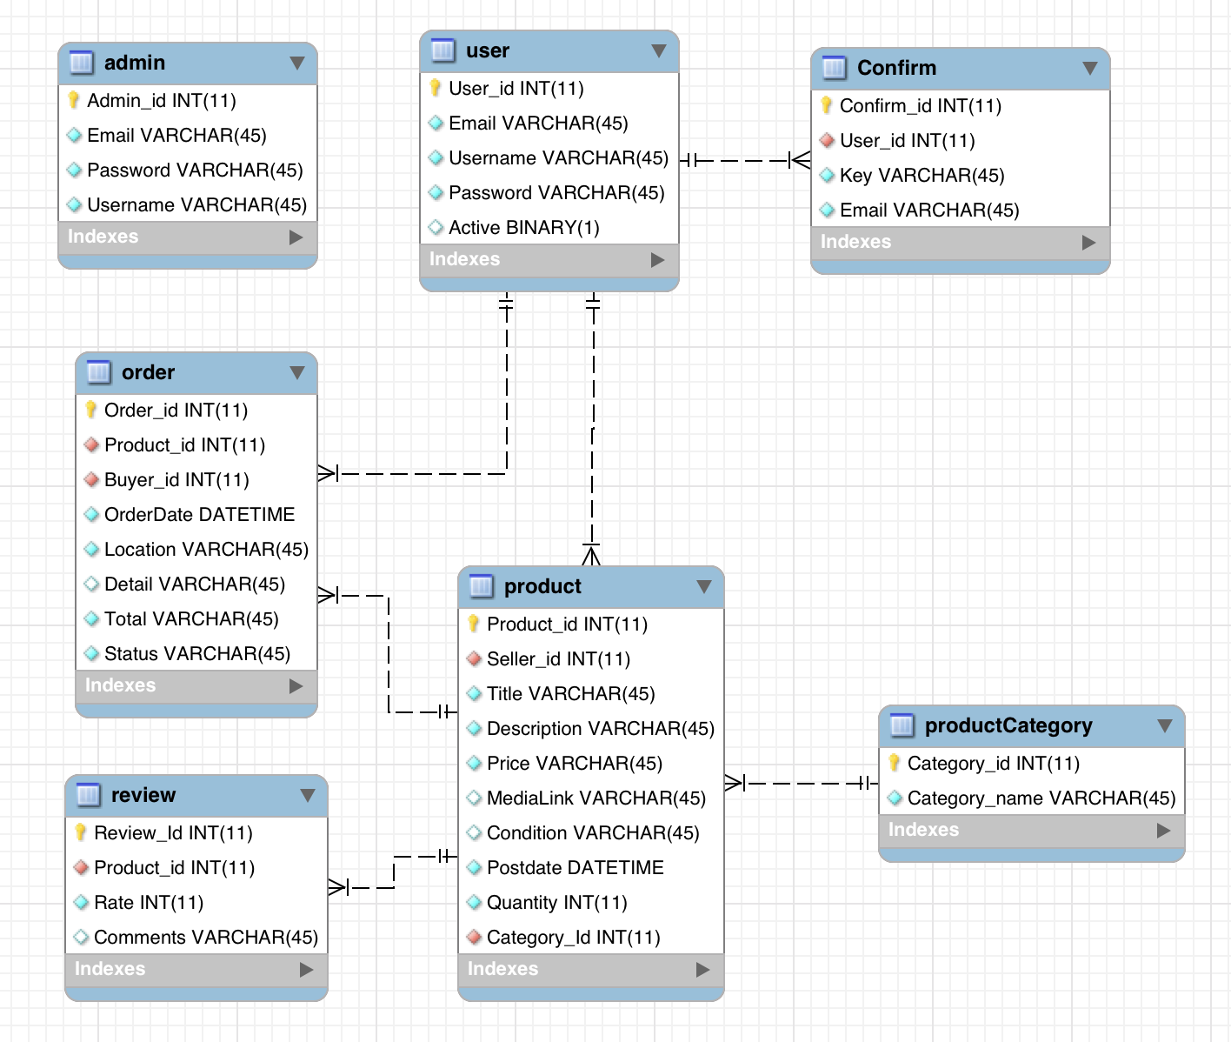

**User Table:**

|  |
| --- |
| **Users** |
| User_id - int PK |
| Username – varchar |
| Email - varchar |
| Password - varchar |
| Active- binary |

**Admin Table:**

|  |
| --- |
| **Admin** |
| Admin_id - int PK |
| Username – varchar |
| Email - varchar |
| Password - varchar |

**Product Table:**

|  |
| --- |
| **Product** |
| Product_id - int PK |
| Seller_id – int FK |
| Category_id – int FK |
| MediaLink - varchar |
| Title - varchar |
| Description- varchar |
| Price- decimal |
| Condition -varchar |
| Postdate - datetime |
| Quantitiy - int |

FK: Seller_id refer to user table;

Category_id refer to productCategory table;

**ProductCategory Table:**

|  |
| --- |
| **ProductCategory** |
| Category_id - int PK |
| Category_name - varchar |

**Order Table:**

|  |
| --- |
| **Order** |
| Order_id - int PK |
| Product_id – int FK |
| Buyer_id – int FK |
| OrderDate - datetime |
| Detail- varchar |
| Total- decimal |
| Location -varchar |
| Status - varchar |

FK: Buyer_id refer to user table;

Product_id refer to product table;

**Review Table:**

|  |
| --- |
| **Review** |
| Review_id - int PK |
| Product_id – int FK |
| Rate – int |
| Comments - varchar |

FK: Product_id refer to product table;

**Confirm Table:**

|  |
| --- |
| **Confirm** |
| Comfirm_id - int PK |
| User_id – int FK |
| Key– varchar |
| Email – varchar |

FK: User_id refer to user table;

1. High Level UML Diagrams

* High-level UML class diagram

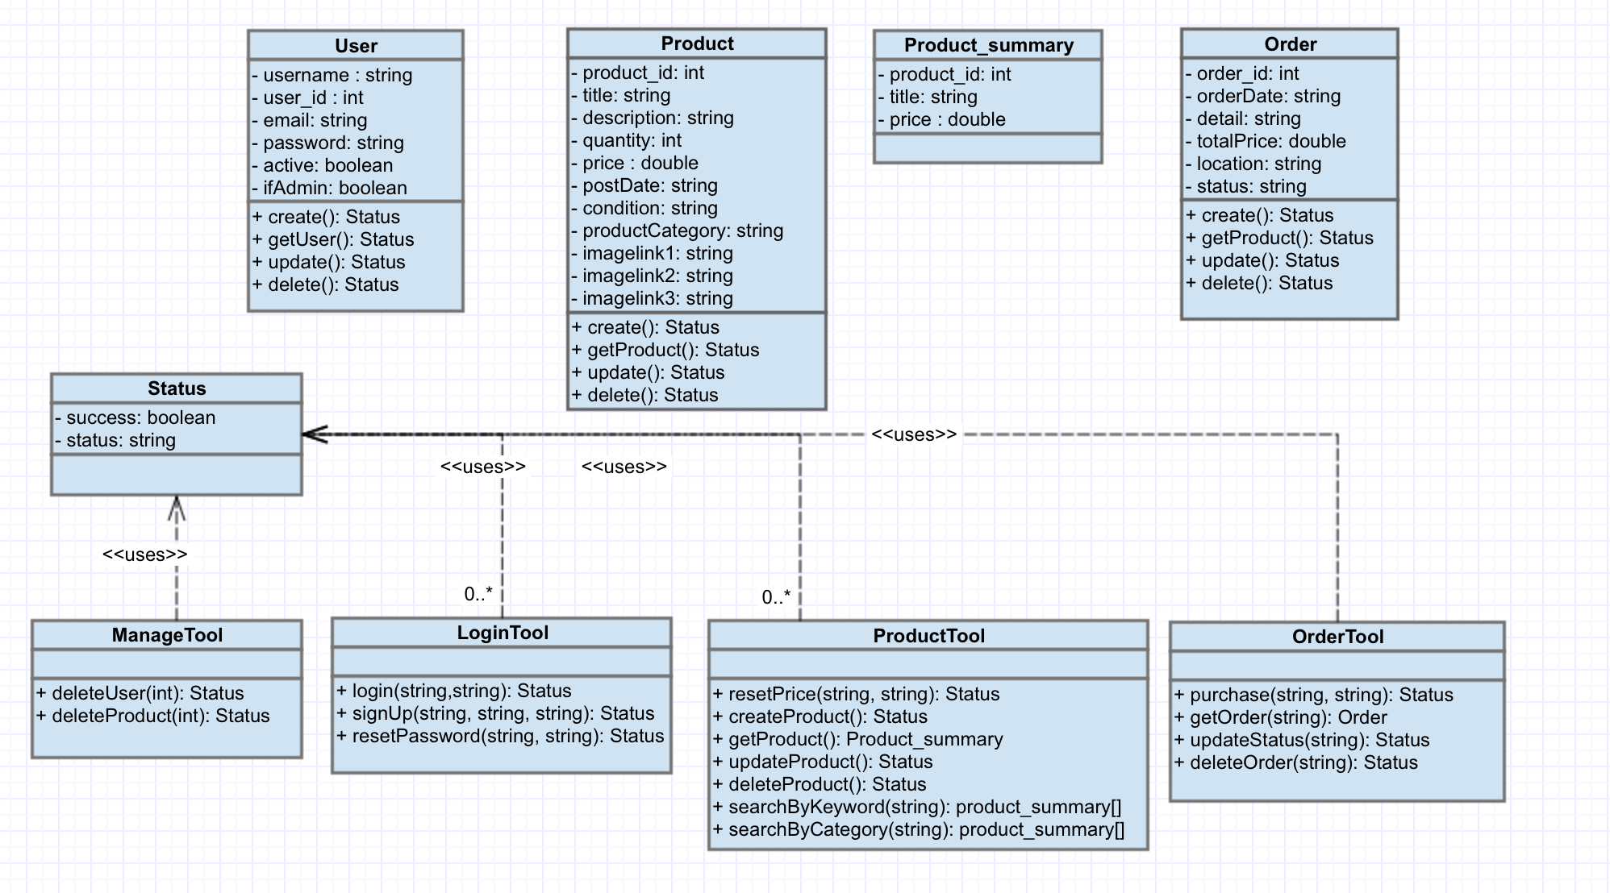

* UML component and deployment diagram

<<TO DO>>

1. High level APIs

**Status :**

- Boolean: success

- String: status

**Login Tool:**

+ login(username STRING, password STRING)

Return: Status

+ signUp(username STRING, password STRING, password STRING)

Return: Status

+ resetUserPassword(username STRING, oldpwd STRING, newpwd STRING)

Return: Status

**Product Tool:**

+ getProduct(product_id INT)

Return: Null - if the product ID is not in the database

Associated array includes

String: Seller’s name

String: Title

Double: Price

String: Condition

Datetime: Postdate

Image

+ getResultsByKeyword(keyword STRING)

Return: Null – if no products contains keyword

Associated array includes

String: Seller’s name

String: Title

Double: Price

String: Condition

Datetime: Postdate

Image

+ getResultsByCategory(Category_id INT)

Return: Null – if no category ID in the database

Associated array includes

String: Seller’s name

String: Title

Double: Price

String: Condition

Datetime: Postdate

Image

+ resetPrice(product_id INT, newprice DOUBLE)

Return: Status

+ deleteProduct(product_id INT)

Return: Status

**Order Tool:**

+ getOrder(order_id INT)

Return:Null – if order ID is not in the database

Associated array includes

String: Product name

String: Buyer’s name

Double: Total

Datetime: OrderDate

String: Status

String: Location

String: Detail

+purchase(product_id INT, user_id INT)

Return: Status

**Manage Tool:**

+deleteUser(user_id INT)

Return: Status

+deleteProduct(product_id INT)

Return: Status

1. Key Risks

<<TO DO>>

1. Team Organization

|  |  |
| --- | --- |
| **Name** | **Initial Role** |
| Khalid Alrashed | Team Lead |
| Eric Chen | Tech Lead/Frontend |
| Robert Chung | Backend |
| Tai Nguyen | Frontend |
| Guoyi Ruan | Backend |